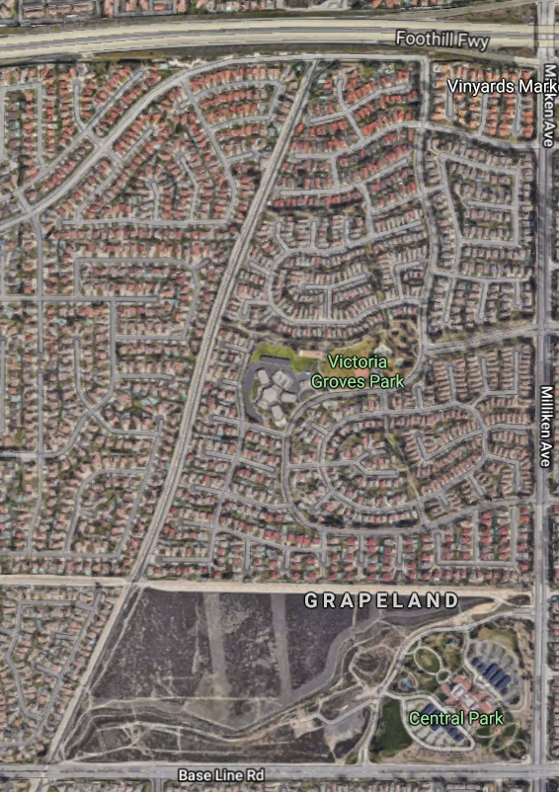

* 

**5K Turn**

**RETURN**

**START/FINISH**

**OUT**

**Fun Run 2K & 5K** *Begins at Rancho Cucamonga CENTRAL PARK

* 

**2K Turn**

**WATER**